

Student Name……………………………………

MATHEMATICAL METHODS UNITS 3 & 4

TRIAL EXAMINATION 1

2017

Reading Time: 15 minutes
Writing time: 1 hour

Instructions to students
This exam consists of 9 questions.
All questions should be answered in the spaces provided.
There is a total of 40 marks available.
The marks allocated to each of the questions are indicated throughout.
Students may not bring any calculators or notes into the exam.
Where a numerical answer is required, an exact value must be given unless otherwise directed.
Where more than one mark is allocated to a question, appropriate working must be shown.
Diagrams in this trial exam are not drawn to scale.
A formula sheet can be found on pages 12 and 13 of this exam.

This paper has been prepared independently of the Victorian Curriculum and Assessment Authority to provide additional exam preparation for students. Although references have been reproduced with permission of the Victorian Curriculum and Assessment Authority, the publication is in no way connected with or endorsed by the Victorian Curriculum and Assessment Authority.

© THE HEFFERNAN GROUP 2017
This Trial Exam is licensed on a non transferable basis to the purchasing school. It may be copied by the school which has purchased it. This license does not permit distribution or copying of this Trial Exam by any other party.
Question 1 (4 marks)

- Differentiate 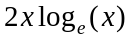 with respect to x. 1 mark

- Let 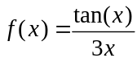.
Evaluate 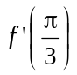. 3 marks

Question 2 (3 marks)

Let 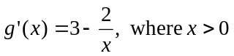. Find 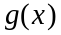 given that 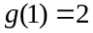.

Question 3 (4 marks)

Let 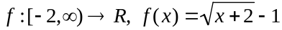.

- Sketch the graph of f. Label the axis intercepts with their coordinates and label any endpoints with their coordinates. 3 marks

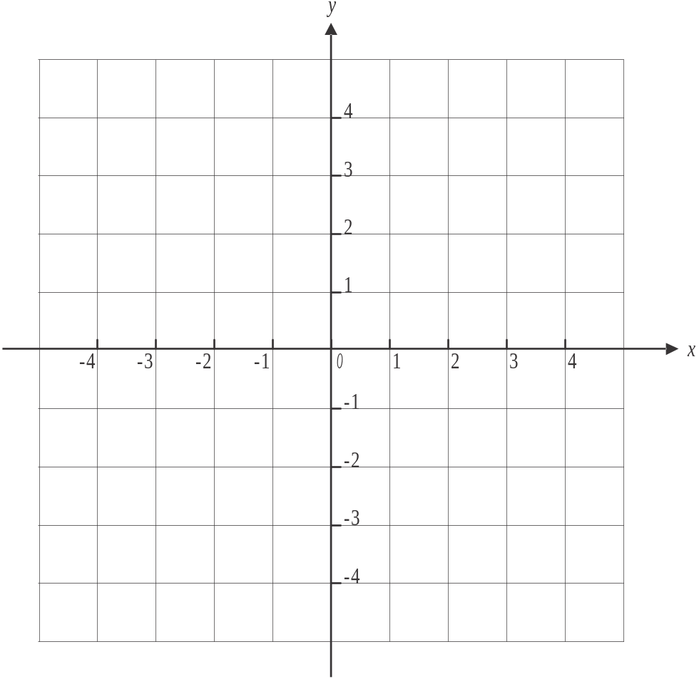

- Find the average rate of change of f between . 1 mark

Question 4 (3 marks)

A class contains 10 girls and 15 boys. The teacher randomly selects one of these 25 students on Monday to have their homework checked.
The teacher repeats this process on Wednesday and again on Friday.

- What is the probability that during this week none of the selected students were girls? 1 mark

- What is the probability that at least two of the students selected during this week were girls? 1 mark

- What is the mean number of girls expected to be selected during such a week? 1 mark

Question 5 (4 marks)

The random variable X is normally distributed with a mean of 24 and a standard deviation of 3. The random variable Z is the standard normal distribution and 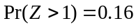, correct to two decimal places.

- Find 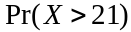. 1 mark

- Find 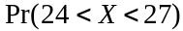. 1 mark

- Find 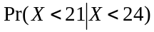. 2 marks

Question 6 (5 marks)

Let 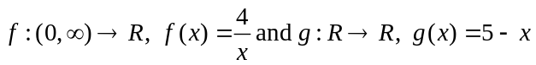.
The graphs of f and g intersect at the points where as shown below.

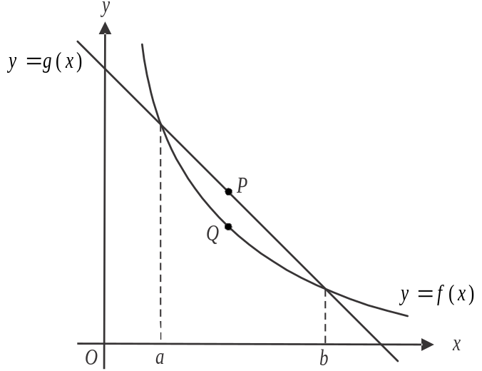

Point P lies on the graph of g between .
Point Q lies on the graph of f between .
Point P lies vertically above point Q.

- Find an expression in terms of x for L, the length of the line segment PQ. 1 mark

- Find the maximum length of the line segment PQ. 2 marks

- The tangent to the graph of f at the point where makes an angle of with the positive branch of the x-axis.
Find . 2 marks

Question 7 (5 marks)

Let 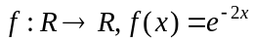.
Part of the graph of f is shown below.
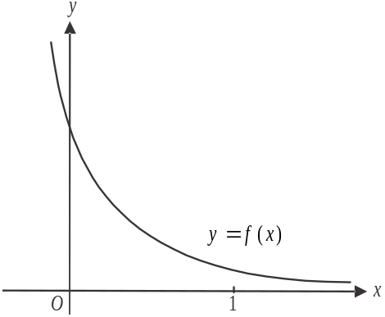

- Find the area enclosed by the graph of 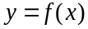, the x and y axes and the line . 2 marks

- Let k equal the average value of f between . Find k. 1 mark

- By using the graph and considering the area of appropriate rectangles, explain why 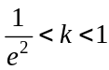. 2 marks

Question 8 (4 marks)

The continuous random variable X has a probability density function given by

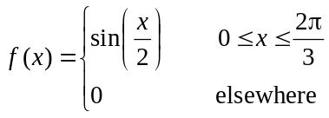

- Show by differentiation that 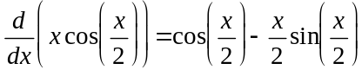. 1 mark

- Hence find 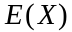. 3 marks

Question 9 (8 marks)

Let 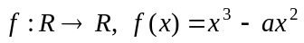, where a is a positive real number.
The graph of f is shown below.
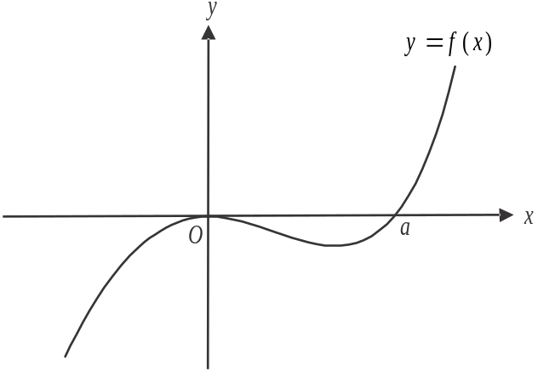

- Find the coordinates of the stationary points of the graph of f. 3 marks

- Find the values of n, where n is a real number, for which the equation 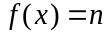 has two solutions. 1 mark

- The point 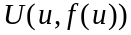 lies on the graph of f.
A tangent is drawn to the graph of f at the point U.
No other tangent to the graph of f has the same gradient as this tangent.
Find u. 2 marks

- The points 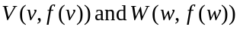 also lie on the graph of f where .
The tangents to the graph of f at the points V and W have the same gradient.
Find . 2 marks

Mathematical Methods formulas

Mensuration
area of a trapezium | 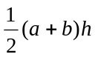 | volume of a pyramid | 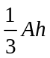
curved surface area of a cylinder | 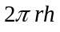 | volume of a sphere | 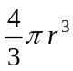
volume of a cylinder | 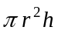 | area of a triangle | 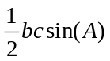
volume of a cone | 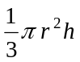

Calculus
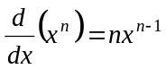 |  | 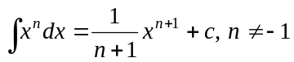
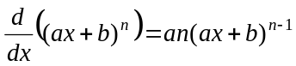 |  | 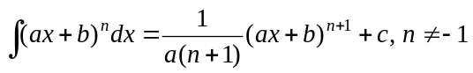
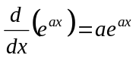 |  | 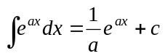
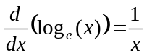 |  | 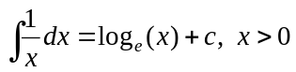
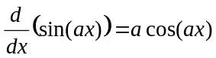 |  | 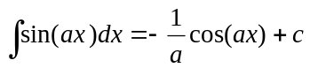
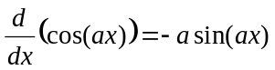 |  | 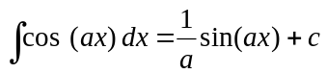
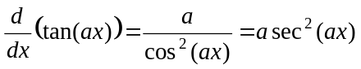
product rule | 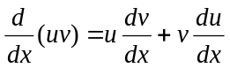 | quotient rule | 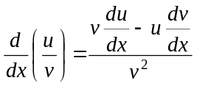
chain rule | 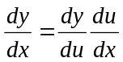
Mathematics Formula Sheets reproduced by permission; © VCAA 2016. The VCAA does not endorse or make any warranties regarding this study resource. Current and past VCAA VCE® exams and related content can be accessed directly at www.vcaa.vic.edu.au

Probability

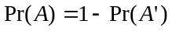
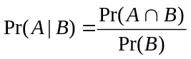
mean | 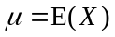 | variance

Probability distribution |  | Mean | Variance
discrete | 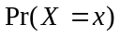=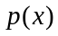 | 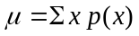 | 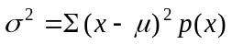
continuous | 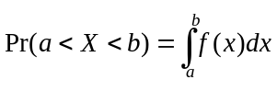 | 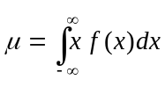 | 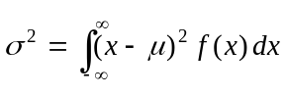

Sample proportions

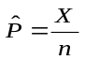 |  | mean | 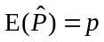
standard  deviation | 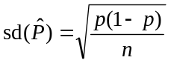 | approximate  confidence  interval | 